1.

OUTPUT:

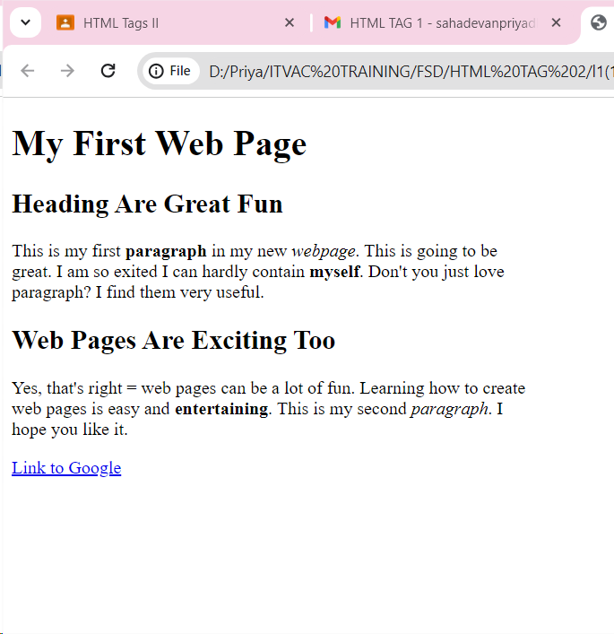

CODE:

<!DOCTYPE html>

<html lang="en">

<head>

<meta charset="UTF-8">

<meta name="viewport" content="width=device-width, initial-scale=1.0">

<title>Document</title>

<style>

body{

width: 470px;

}

</style>

</head>

<body>

<h1>My First Web Page</h1>

<h2>Heading Are Great Fun</h2>

<P>This is my first <b>paragraph</b> in my new <i>webpage</i>. This is going to be great. I am so exited I can hardly contain <b>myself</b>. Don't you just love paragraph? I find them very useful.</P>

<h2>Web Pages Are Exciting Too</h2>

<p>Yes, that's right = web pages can be a lot of fun. Learning how to create web pages is easy and <b>entertaining</b>. This is my second <i>paragraph</i>. I hope you like it.</p>

<a href="www.google.com">Link to Google</a>

</body>

</html>

OUTPUT:

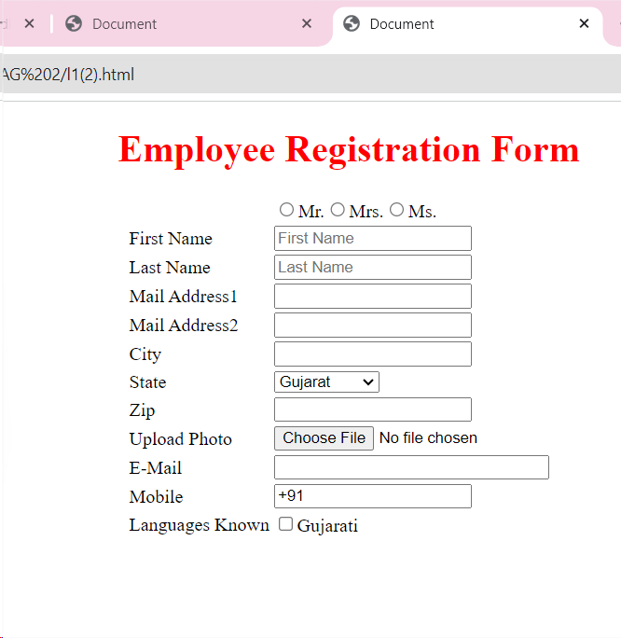

CODE:

<!DOCTYPE html>

<html lang="en">

<head>

<meta charset="UTF-8">

<meta name="viewport" content="width=device-width, initial-scale=1.0">

<title>Document</title>

<style>

h1{

color:red;

}

</style>

</head>

<body>

<center>

<h1>Employee Registration Form</h1>

<form>

<table>

<tr>

<td><label for="st"> </label></td>

<td><input type="radio" id="st" name="sta">Mr.<input type="radio" id="st" name="sta">Mrs.<input type="radio" id="st" name="sta">Ms.</td>

</tr>

<tr>

<td><label for="fname">First Name</label></td>

<td><input type="text" id="fname" placeholder="First Name"></td>

</tr>

<tr>

<td><label for="lname">Last Name</label></td>

<td><input type="text" id="lname" placeholder="Last Name"></td>

</tr>

<tr>

<td><label for="mail1">Mail Address1</label></td>

<td><input type="email" id="mail1"/></td>

</tr>

<tr>

<td><label for="mail2">Mail Address2</label></td>

<td><input type="email" id="mail2"/></td>

</tr>

<tr>

<td><label for="city">City</label></td>

<td><input type="email" id="city"/></td>

</tr>

<tr>

<td><label for="state">State</label></td>

<td><select id="state">

<option>Gujarat</option>

<option>Tamil Nadu</option>

<option>Kerala</option>

<option>Karnataka</option>

<option>Rajasthan</option>

</select>

</td>

</tr>

<tr>

<td><label for="zip">Zip</label></td>

<td><input type="text" id="zip"></td>

</tr>

<tr>

<td><label for="upload">Upload Photo</label></td>

<td><input type="file" id="upload"></td>

</tr>

<tr>

<td><label for="email">E-Mail</label></td>

<td><input type="email" id="email" size="30"></td>

</tr>

<tr>

<td><label for="mobile">Mobile</label></td>

<td><input type="tel" id="mobile" value="+91"></td>

</tr>

<tr>

<td><label for="lang">Languages Known</label></td>

<td><input type="checkbox" id="lang">Gujarati</td>

</tr>

</table>

</form>

</center>

</body>

</html>

3.

OUTPUT:

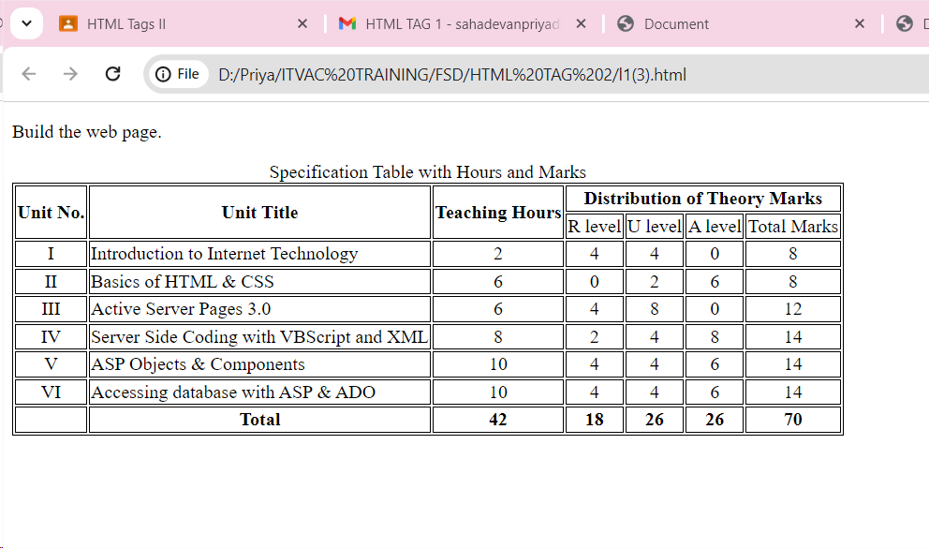

CODE:

<!DOCTYPE html>

<html lang="en">

<head>

<meta charset="UTF-8">

<meta name="viewport" content="width=device-width, initial-scale=1.0">

<title>Table</title>

<style>

table,td,th{

border:1px solid black;

text-align: center;

}

.left

{

text-align: left;

}

</style>

</head>

<body>

<p>Build the web page.</p>

<table>

<caption>Specification Table with Hours and Marks</caption>

<tr>

<th rowspan="2">Unit No.</th>

<th rowspan="2">Unit Title</th>

<th rowspan="2">Teaching Hours</th>

<th colspan="4">Distribution of Theory Marks</th>

</tr>

<tr>

<td>R level</td>

<td>U level</td>

<td>A level</td>

<td>Total Marks</td>

</tr>

<tr>

<td>I</td>

<td class="left">Introduction to Internet Technology</td>

<td>2</td>

<td>4</td>

<td>4</td>

<td>0</td>

<td>8</td>

</tr>

<tr>

<td>II</td>

<td class="left">Basics of HTML & CSS</td>

<td>6</td>

<td>0</td>

<td>2</td>

<td>6</td>

<td>8</td>

</tr>

<tr>

<td>III</td>

<td class="left">Active Server Pages 3.0</td>

<td>6</td>

<td>4</td>

<td>8</td>

<td>0</td>

<td>12</td>

</tr>

<tr>

<td>IV</td>

<td class="left">Server Side Coding with VBScript and XML</td>

<td>8</td>

<td>2</td>

<td>4</td>

<td>8</td>

<td>14</td>

</tr>

<tr>

<td>V</td>

<td class="left">ASP Objects & Components</td>

<td>10</td>

<td>4</td>

<td>4</td>

<td>6</td>

<td>14</td>

</tr>

<tr>

<td>VI</td>

<td class="left">Accessing database with ASP & ADO</td>

<td>10</td>

<td>4</td>

<td>4</td>

<td>6</td>

<td>14</td>

</tr>

<tr>

<!--<td></td>

<td><b>Total</b></td>

<td><b>42</b></td>

<td><b>18</b></td>

<td><b>26</b></td>

<td><b>26</b></td>

<td><b>70</b></td>-->

<th></th>

<th>Total</th>

<th>42</th>

<th>18</th>

<th>26</th>

<th>26</th>

<th>70</th>

</tr>

</table>

</body>

</html>

4.

OUTPUT:

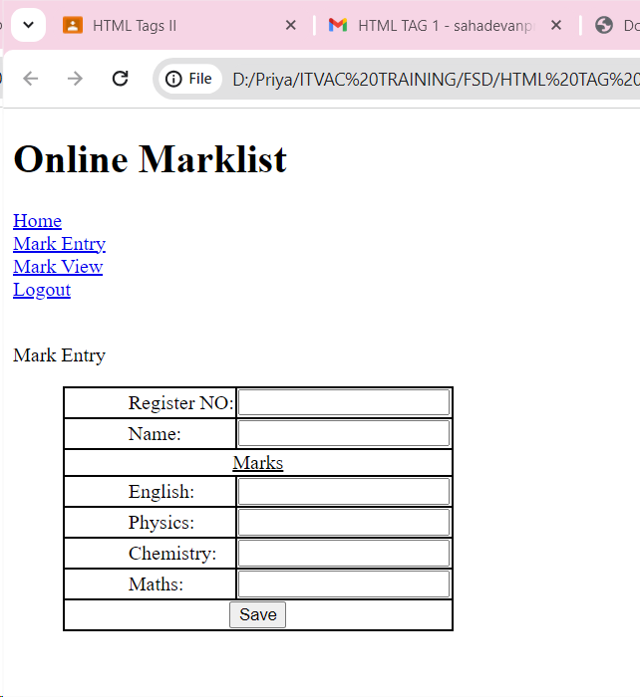

CODE:

<!DOCTYPE html>

<html lang="en">

<head>

<meta charset="UTF-8">

<meta name="viewport" content="width=device-width, initial-scale=1.0">

<title>Online Marklist</title>

<style>

table{

border-spacing:0px;

}

table,td{

border:1px solid black;

}

label{

padding-left: 50px;

text-align: left;

}

input{

text-align: left;

}

.space{

padding-left: 40px;

}

</style>

</head>

<body>

<h1>Online Marklist</h1>

<a href="#">Home</a><br>

<a href="#">Mark Entry</a><br>

<a href="#">Mark View</a><br>

<a href="#">Logout</a><br>

<br>

<p>Mark Entry</p>

<div class="space">

<table>

<tr>

<td><label for="reg">Register NO:</label></td>

<td><input type="text" id="reg"></td>

</tr>

<tr>

<td><label for="name">Name:</label></td>

<td><input type="text" id="name"></td>

</tr>

<tr>

<td colspan="2"><center><u>Marks</u></center></td>

</tr>

<tr>

<td><label for="eng">English:</label></td>

<td><input type="text" id="eng"></td>

</tr>

<tr>

<td><label for="phy">Physics:</label></td>

<td><input type="text" id="phy"></td>

</tr>

<tr>

<td><label for="che">Chemistry:</label></td>

<td><input type="text" id="che"></td>

</tr>

<tr>

<td><label for="mat">Maths:</label></td>

<td><input type="text" id="mat"></td>

</tr>

<tr>

<td colspan="2"><center><button type="submit">Save</center></button></td>

</tr>

</table>

</div>

</body>

</html>

5.

OUTPUT:

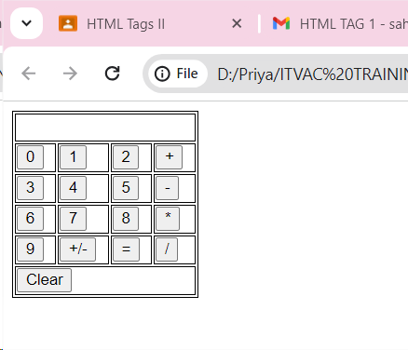

CODE:

<!DOCTYPE html>

<html lang="en">

<head>

<meta charset="UTF-8">

<meta name="viewport" content="width=device-width, initial-scale=1.0">

<title>Calculator</title>

<style>

table,td

{

border:1px solid black;

}

td

{

height: 20px;

padding-right: 10px;

}

</style>

</head>

<body>

<table>

<tr>

<td colspan="4"></td>

</tr>

<tr>

<td><button type="submit">0</button></td>

<td><button type="submit">1</button></td>

<td><button type="submit">2</button></td>

<td><button type="submit">+</button></td>

</tr>

<tr>

<td><button type="submit">3</button></td>

<td><button type="submit">4</button></td>

<td><button type="submit">5</button></td>

<td><button type="submit">-</button></td>

</tr>

<tr>

<td><button type="submit">6</button></td>

<td><button type="submit">7</button></td>

<td><button type="submit">8</button></td>

<td><button type="submit">\*</button></td>

</tr>

<tr>

<td><button type="submit">9</button></td>

<td><button type="submit">+/-</button></td>

<td><button type="submit">=</button></td>

<td><button type="submit">/</button></td>

</tr>

<tr>

<td colspan="4"><button type="submit">Clear</button></td>

</tr>

</table>

</body>

</html>

6.

OUTPUT:

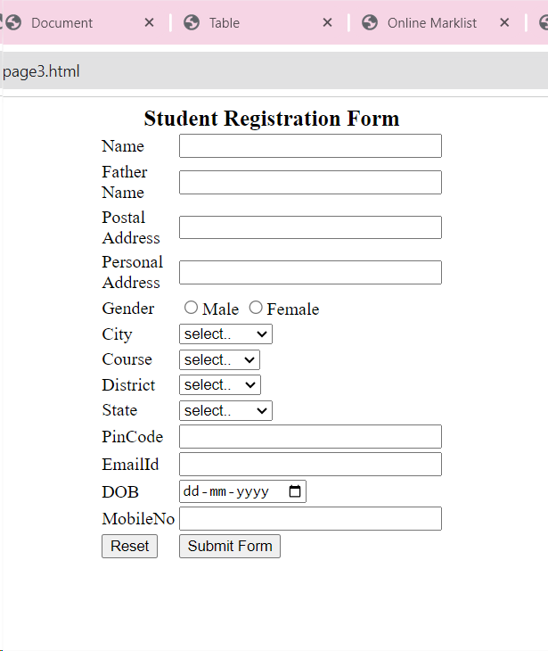

CODE:

<!DOCTYPE html>

<html lang="en">

<head>

<meta charset="UTF-8">

<meta name="viewport" content="width=device-width, initial-scale=1.0">

<title>Student</title>

<style>

caption

{

font-size: 20px;

}

</style>

</head>

<body>

<center>

<form>

<table>

<caption><b>Student Registration Form</b></caption>

<tr>

<td><label for="name">Name</label></td>

<td><input type="text" id="name" size="30"></td>

</tr>

<tr>

<td><label for="fname">Father<br>Name</label></td>

<td><input type="text" id="fname" size="30"></td>

</tr>

<tr>

<td><label for="poadd">Postal<br>Address</label></td>

<td><input type="text" id="poadd" size="30"></td>

</tr>

<tr>

<td><label for="peradd">Personal<br>Address</label></td>

<td><input type="text" id="peradd" size="30"></td>

</tr>

<tr>

<td><label for="gender">Gender</label></td>

<td><input type="radio" id="gender" name="gen" >Male <input type="radio" id="gender" name="gen">Female</td>

</tr>

<tr>

<td><label for="city">City</label></td>

<td><select id="city" >

<option disabled selected>select..</option>

<option>New Delhi</option>

<option>Mumbai</option>

<option>Goa</option>

<option>Patna</option>

</select></td>

</tr>

<tr>

<td><label for="course">Course</label></td>

<td><select id="course">

<option disabled selected>select..</option>

<option>B.TECH</option>

<option>MCA</option>

<option>MBA</option>

<option>BCA</option>

</select></td>

</tr>

<tr>

<td><label for="district">District</label></td>

<td><select id="district">

<option disabled selected>select..</option>

<option>Nalanda</option>

<option>UP</option>

<option>Goa</option>

<option>Patna</option>

</select></td>

</tr>

<tr>

<td><label for="state">State</label></td>

<td><select id="state">

<option disabled selected>select..</option>

<option>New Delhi</option>

<option>Mumbai</option>

<option>patna</option>

<option>Goa</option>

</select></td>

</tr>

<tr>

<td><label for="pin">PinCode</label></td>

<td><input type="text" id="pin" size="30"></td>

</tr>

<tr>

<td><label for="email">EmailId</label></td>

<td><input type="email" id="email" size="30"></td>

</tr>

<tr>

<td><label for="dob">DOB</label></td>

<td><input type="date" id="dob" size="30"></td>

</tr>

<tr>

<td><label for="ph">MobileNo</label></td>

<td><input type="tel" id="ph" size="30"></td>

</tr>

<tr>

<td><button type="submit">Reset</button></td>

<td><button type="submit">Submit Form</button></td>

</tr>

</table>

</form>

</center>

</body>

</html>

7.

OUTPUT:

<!DOCTYPE html>

<html lang="en">

<head>

<meta charset="UTF-8">

<meta name="viewport" content="width=device-width, initial-scale=1.0">

<title>Education details</title>

<style>

table{

border : 3px solid grey;

border-spacing: 5px;

}

td,th{

border: 1px solid black;

padding:3px;

}

</style>

</head>

<body>

<h1>EDUCATION DETAILS</h1>

<br>

<table>

<tr>

<th>SNo</th>

<th>Course</th>

<th>Board/University</th>

<th>School/College</th>

<th>Year of Passing</th>

<th>Percentage</th>

</tr>

<tr>

<td>1</td>

<td>10</td>

<td>ICSE</td>

<td>DPS</td>

<td>2008</td>

<td>90</td>

</tr>

<tr>

<td>2</td>

<td>12</td>

<td>ICSE</td>

<td>DPS</td>

<td>2010</td>

<td>95</td>

</tr>

</table>

</body>

</html>

8.

OUTPUT:

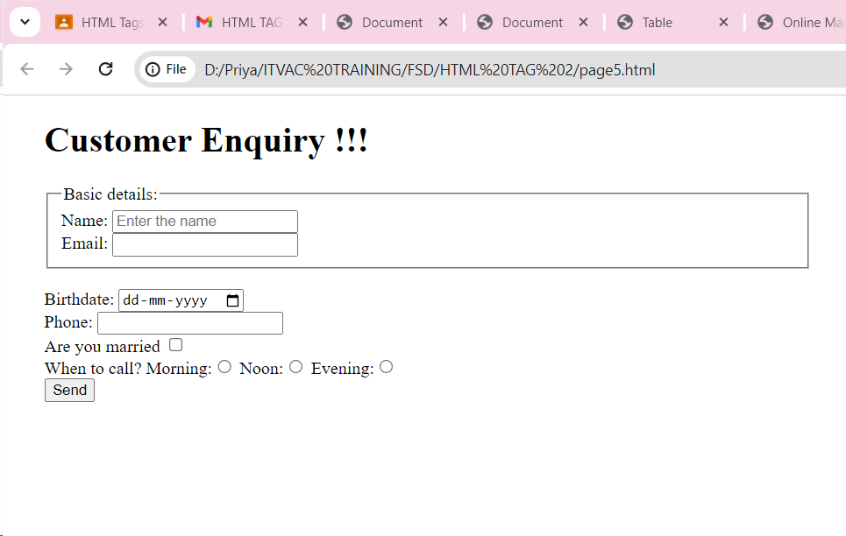

CODE:

<!DOCTYPE html>

<html lang="en">

<head>

<meta charset="UTF-8">

<meta name="viewport" content="width=device-width, initial-scale=1.0">

<title>Customer Enquiry</title>

<style>

body{

padding-left: 30px;

width:700px;

}

</style>

</head>

<body>

<h1>Customer Enquiry !!!</h1>

<form>

<fieldset>

<legend>Basic details:</legend>

<label for="name">Name:</label>

<input type="text" id="name" placeholder="Enter the name"><br>

<label for="email">Email:</label>

<input type="email" id="email" >

</fieldset>

<br>

<label for="birth">Birthdate:</label>

<input type="date" id="birth"><br>

<label for="ph">Phone:</label>

<input type="tel" id="ph"><br>

<label for="status">Are you married</label>

<input type ="checkbox" id="status"><br>

<label for="call">When to call?</label>

Morning:<input type="radio" id="call" name="ca">

Noon:<input type="radio" id="call" name="ca">

Evening:<input type="radio" id="call" name="ca"><br>

<input type="submit" value="Send">

</form>

</body>

</html>

9.

OUTPUT:

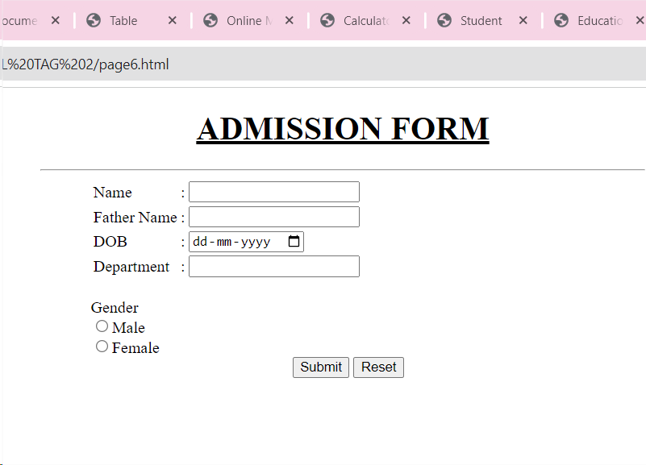

CODE:

<!DOCTYPE html>

<html lang="en">

<head>

<meta charset="UTF-8">

<meta name="viewport" content="width=device-width, initial-scale=1.0">

<title>Admission</title>

<style>

.space

{

padding-left: 200px;

}

.box

{

width:600px;

text-align: left;

}

form{

padding-left: 50px;

}

</style>

</head>

<body>

<center>

<div class="box">

<center>

<h1><u>ADMISSION FORM</u></h1>

</center>

<hr>

<form>

<table>

<tr>

<td><label for="name">Name</label></td>

<td>:</td>

<td><input type="text" id ="name" size="20"></td>

</tr>

<tr>

<td><label for="fname">Father Name</label></td>

<td>:</td>

<td><input type="text" id ="fname" size="20"></td>

</tr>

<tr>

<td><label for="dob">DOB</label></td>

<td>:</td>

<td><input type="date" id ="dob" size="20"></td>

</tr>

<tr>

<td><label for="dept">Department</label></td>

<td>:</td>

<td><input type="text" id ="dept" size="20"></td>

</tr>

</table>

<br>

<label for="gen">Gender</label><br>

<input type="radio" id ="gen" name="gender">Male<br>

<input type="radio" id ="gen" name="gender">Female<br>

<div class="space"><button type="submit">Submit</button> <button type="submit">Reset</button></div>

</form>

</div>

</center>

</body>

</html>